

W6 PRACTICE
FORMS & INPUTS
 What are the objectives for this session?
- Learn and use various HTML form input types o text, checkbox, radio, dropdown, text area, range, color, selector etc.

- Apply basic CSS styles to enhance the appearance of form inputs o borders, colors, padding, margins etc.

- Use: :focus :hover : checked :checked :indeterminate CSS pseudo-classes

 How to start?
- Download the start code from the LMS
- Open the folder in VS Code
How to submit your work?
- Push your final code on your GitHub repository
- Then attach the GitHub path to the MS Team assignment and turn it in

 Are you lost?
You can read the following documentation to be ready for this practice:
- Guide - WC3 School
- The Form element
- HTML Forms



PART 1: LEARN – 45 MIN

- Read or watch resources on internet to learn about HTML Inputs:
Guide - WC3 School
The Form element
HTML Forms

- Complete the bellow table.

INPUT TYPE | USAGE | EXAMPLE
Text | defines a one-line input field for text input | <input type="text">
radio | Let a user select one of a limited number of choices | <input type="radio">
checkbox | Let a user select zero or more options of a limited number of choices | <input type="checkbox">
range | Let the user select a numeric value from a range of value | <input type="range">
submit | Defines a button for submitting the form data to a form-handler | <input type="submit">
textarea | Let a user enter a multi-line text input | <textarea></textarea>
select | Let a user select from a dropdown list of options | <select>  <option>Option 1</option>  <option>Option 2</option>  </select>
color | Let a user select a color | <input type="color">
file | Let a user choose and upload a file | <input type="file">

- Read or watch resources on internet to learn about Inputs styling:
https://www.w3schools.com/css/css_form.asp
- Complete those mini challenges by writing your code on bellow table:
MINI CHALLENGES | YOUR CODE (HTML + CSS)
Highlight the input field when it is focused | <!DOCTYPE html>  <html lang="en">  <head>  <meta charset="UTF-8">  <meta name="viewport" content="width=device-width, initial-scale=1.0">  <title>Challenge 1</title>  <style>  * {  margin: 0;  padding: 0;  box-sizing: border-box;  }  body {  padding: 20px;  }  label {  display: block;  }  input[type=text] {  width: 300px;  padding: 12px;  margin: 8px 0;  border: 1px solid #555;  outline: none;  }  input[type=text]:focus {  background-color: lightblue;  }  </style>  </head>  <body>  <form action="#">  <label for="fname"> First Name:</label>  <input type="text" id="fname" name="fname" placeholder="Enter your first name">  <label for="lname"> Last Name:</label>  <input type="text" id="lname" name="lname" placeholder="Enter your last name">  </form>  </body>  </html>
Change the button background color on hover | <!DOCTYPE html>  <html lang="en">  <head>  <meta charset="UTF-8">  <meta name="viewport" content="width=device-width, initial-scale=1.0">  <title>Challenge 2</title>  <style>  * {  margin: 0;  padding: 0;  box-sizing: border-box;  }  body {  display: flex;  justify-content: center;  margin-top: 20px;  }  input[type=button] {  background-color: dodgerblue;  border: none;  border-radius: 10px;  width: 125px;  color: white;  font-size: 1.2rem;  font-family: Arial;  padding: 15px;  text-align: center;  cursor: pointer;  transition: background-color 0.3s ease;  }  input[type=button]:hover {  background-color:rgb(9, 119, 179);  }  </style>  </head>  <body>  <form action="#">  <input type="button" value="Button">  </form>  </body>  </html>
Create a search bar with rounded corners and a shadow effect | <!DOCTYPE html>  <html lang="en">  <head>  <meta charset="UTF-8">  <meta name="viewport" content="width=device-width, initial-scale=1.0">  <title>Challenge 3</title>  <style>  * {  margin: 0;  padding: 0;  box-sizing: border-box;  }  body {  margin: 20px;  }  .search {  display: block;  border: none;  padding: 12px 16px;  font-size: 16px;  width: 500px;  border-radius: 30px;  box-shadow: 0 1px 6px rgba(0, 0, 0, 0.2);  }  </style>  </head>  <body>  <form action="#">  <input type="text" name="search" class="search" placeholder="Search Google or type URL" >  </form>  </body>  </html>
Display a different style when the checkbox is checked | <!DOCTYPE html>  <html lang="en">  <head>  <meta charset="UTF-8">  <meta name="viewport" content="width=device-width, initial-scale=1.0">  <title>Challenge 4</title>  <style>  input[type=checkbox] {  display: none;  }  label {  display: inline-block;  padding: 10px 20px;  border: 2px solid #3498db;  background-color: #ecf0f1;  color: #34495e;  font-size: 18px;  font-weight: bold;  cursor: pointer;  border-radius: 8px;  text-align: center;  transition: all 0.3s ease;  }  input[type=checkbox]:checked + label {  border-color: #27ae60;  background-color: #2ecc71;  color: white;  box-shadow: 0 4px 10px rgba(0, 0, 0, 0.2);  }  </style>  </head>  <body>  <form action="#">  <input type="checkbox" id="toggle-style">  <label for="toggle-style">Click to change style!</label>  </form>  </body>  </html>
HARD!  Style a checkbox to have three states: unchecked, checked, and indeterminate.  TIP  Use CSS pseudo-classes  (:checked and :indeterminate) for styling. | <!DOCTYPE html>  <html lang="en">  <head>  <meta charset="UTF-8">  <meta name="viewport" content="width=device-width, initial-scale=1.0">  <title>Challenge 5</title>  <style>  * {  margin: 0;  padding: 0;  box-sizing: border-box;  }  body {  margin: 20px;  }  form {  display: flex;  align-items: center;  cursor: pointer;  font-family: sans-serif;  }  input[type="checkbox"] {  display: none;  }  #myCheckbox {  position: absolute;  opacity: 0;  width: 0; height: 0;  }  .custom-checkbox::before {  content: '';  display: inline-block;  width: 20px;  height: 20px;  margin-right: 8px;  border: 2px solid #555;  border-radius: 4px;  vertical-align: middle;  transition: all 0.2s ease-in-out;  }  .custom-checkbox::after {  content: '';  position: absolute;  opacity: 0;  transition: opacity 0.2s ease-in-out;  }  .custom-checkbox {  position: relative;  padding-left: 28px;  line-height: 20px;  user-select: none;  }  #myCheckbox:checked + .custom-checkbox::before {  background-color: #27ae60;  border-color: #27ae60;  }  #myCheckbox::checked + .custom-checkbox::after {  content: '';  opacity: 1;  left: 4px;  top: 2px;  width: 6px;  height: 12px;  border: solid white;  border-width: 0 3px 3px 0;  }  #myCheckbox:indeterminate + .custom-checkbox::before {  background-color: #f39c12;  border-color: #f39c12;  }  #myCheckbox:indeterminate + .custom-checkbox::before {  content: '';  opacity: 1;  top: 10px; /* Center vertically */  left: 4px;  width: 16px; /* Width of the dash */  height: 2px; /* Thickness of the dash */  background-color: white;  transform: none;  }  </style>  </head>  <body>  <form action="#">  <input type="checkbox" id="myCheckbox">  <label for="myCheckbox" class="custom-checkbox">Three-state checkbox</label>  </form>  <script>  document.addEventListener('DOMContentLoaded', () => {  const checkbox = document.getElementById('myCheckbox');  checkbox.indeterminate = true;  checkbox.addEventListener('click', function(envent){  if(this.checked && !this.indeterminate){}  else if(this.indeterminate){  envent.preventDefault();  this.indeterminate = false;  this.checked = false;  }  });  });  </script>  </body>  </html>

- Some groups will be selected to present and explain their work to the whole class

PART 2: PRACTICE – 45 MIN

You need to reproduce – as close as possible - the bellow table.

Before coding, identify the following point:

- Elements: What are the different inputs you will need?

- Layout: what kind of CSS layout do you need? Why?

- Input styling: What are the styles you need to apply on your inputs?

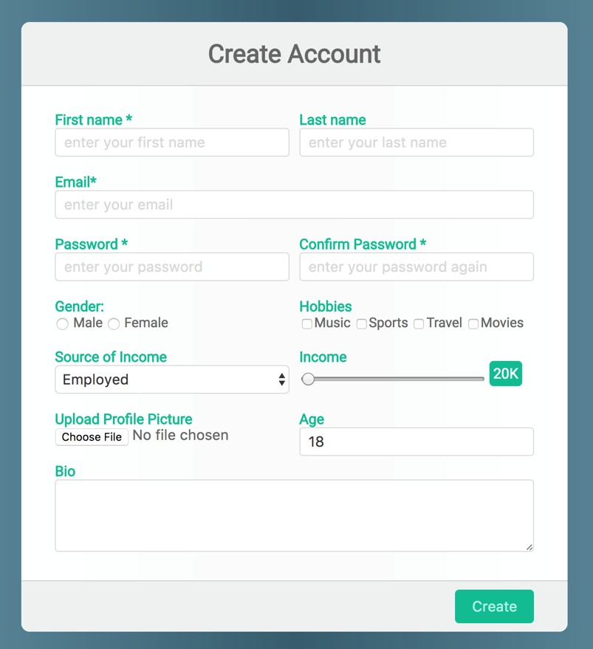
Be as close as possible from this mock up

